**Configuration Settings**

Configuration (or configuration settings) are the constant key/value pairs that are set at a common location and can be read from anywhere in the same application.

Examples: connection strings, Client ID & API keys to make REST-API calls, Domain names, Constant email addresses etc.

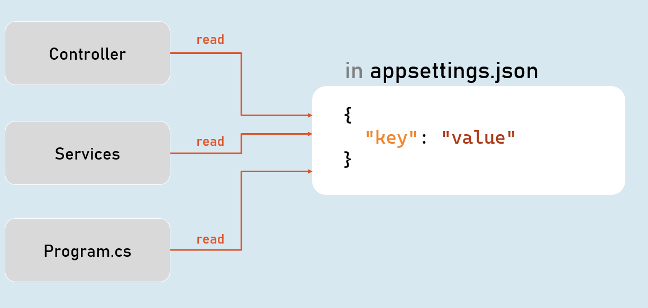

**Configuration Sources**

1. appsettings.json
2. Environment Variables
3. File Configuration (JSON, INI or XML files)
4. In-Memory Configuration
5. Secret Manager

**Access Configuration**

in Program.cs:

app.Configuration

**IConfiguration**

**[string key]**

Gets or sets configuration value at the specified key.

**GetValue<T>(string key, object defaultValue)**

Gets the configuration value at the specified key; returns the default value if the key doesn't exists.

**IConfiguration in Controller**

**in Controller and other classes**

using Microsoft.AspNetCore.Mvc;

using Microsoft.Extensions.Configuration;

public class ControllerName : Controller

{

private readonly IConfiguration _configuration;

public ControllerName(IConfiguration configuration)

{

_configuration = configuration;

}

}

**Hierarchical Configuration**

**in appsettings.json**

{

"MasterKey":

{

"Key1": "value"

"Key2": "value"

}

}

**to read configuration**

Configuration["MasterKey:Key1"]

**IConfiguration.GetSection(string key)**

Returns an IConfigurationSection based on the specified key.

**Options Pattern**

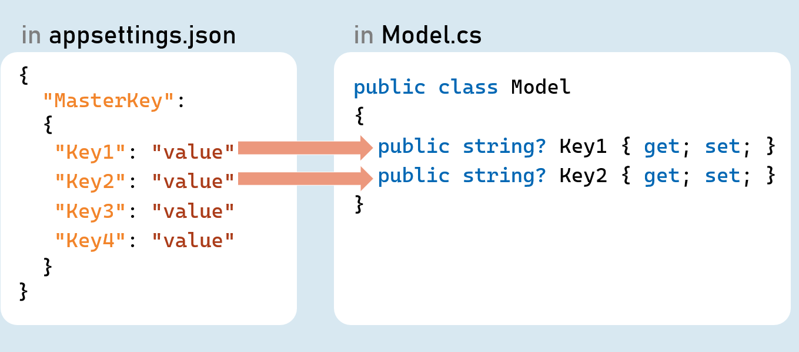

Options pattern uses custom classes to specify what configuration settings are to be loaded into properties.

Examples: Reading the specific connections strings out of many configuration settings.

The option class should be a non-abstract class with a public parameterless constructor.

Public read-write properties are bound.

Fields are not bound.

**IConfiguration.GetSection(string key)**

Returns an IConfigurationSection based on the specified key.

**IConfiguration.Bind(object instance) and IConfiguration.Get<T>()**

Binds (loads) configuration key/value pairs into a new object of the specified type.

**Configuration as Service**

**Inject Configuration as Service**

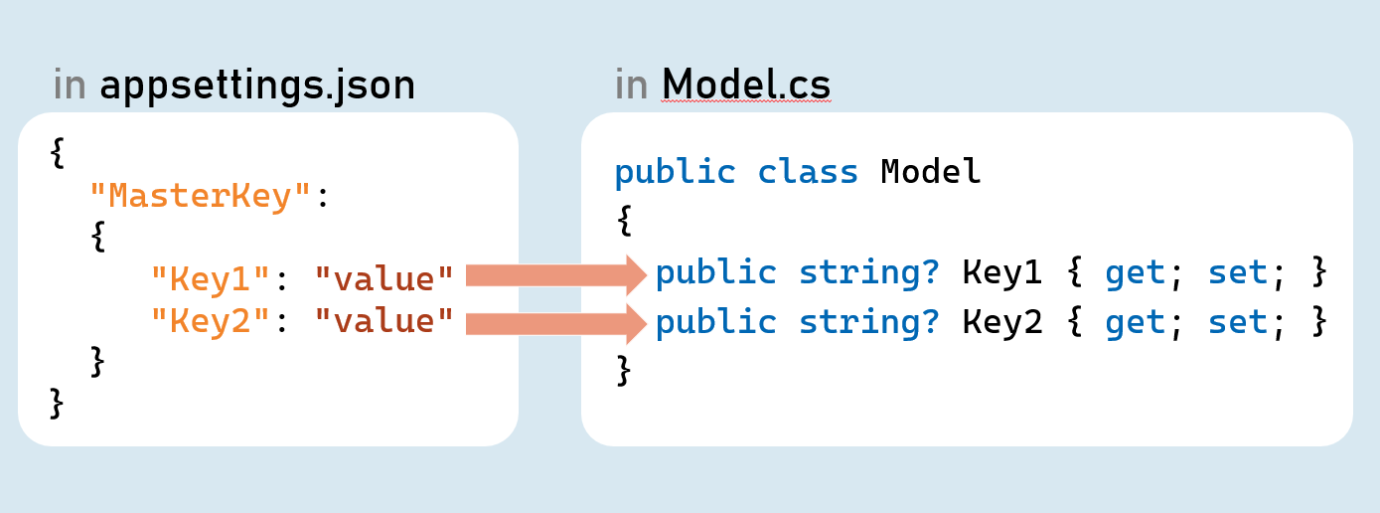

**Add Configuration as Service**

in Program.cs:

builder.Services.Configure<Model>(builder.Configuration.GetSection("MasterKey"));

**Inject Configuration as Service in Controller in Controller and other classes**

using Microsoft.AspNetCore.Mvc;

using Microsoft.Extensions.Options;

public class ControllerName : Controller

{

private readonly Model _options;

public ControllerName(IOptions<Model> options)

{

_options = options.Value;

}

}

**Environment Specific Configuration**

Order of Precedence of Configuration Sources

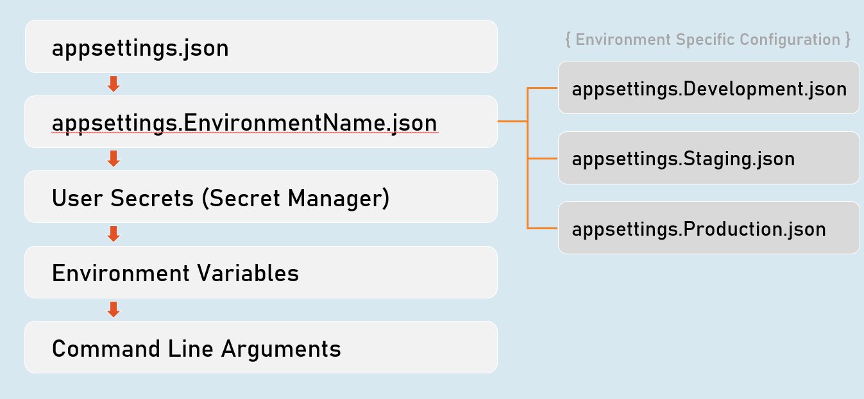

**Secrets Manager**

The 'secrets manager ' stores the user secrets (sensitive configuration data) in a separate location on the developer machine.

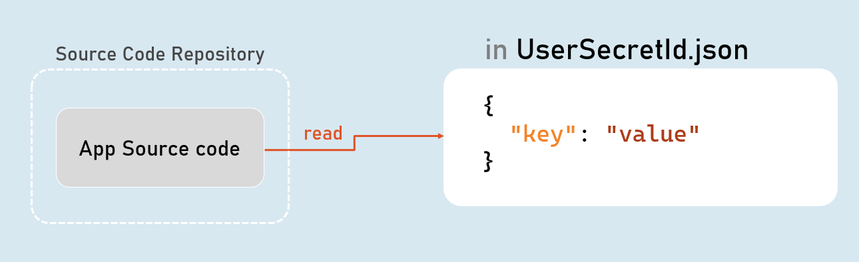

**Enable Secrets Manager in "Windows PowerShell" / "Developer PowerShell in VS"**

dotnet user-secrets init

dotnet user-secrets set "Key" "Value"

dotnet user-secrets list

**Environment Variables Configuration**

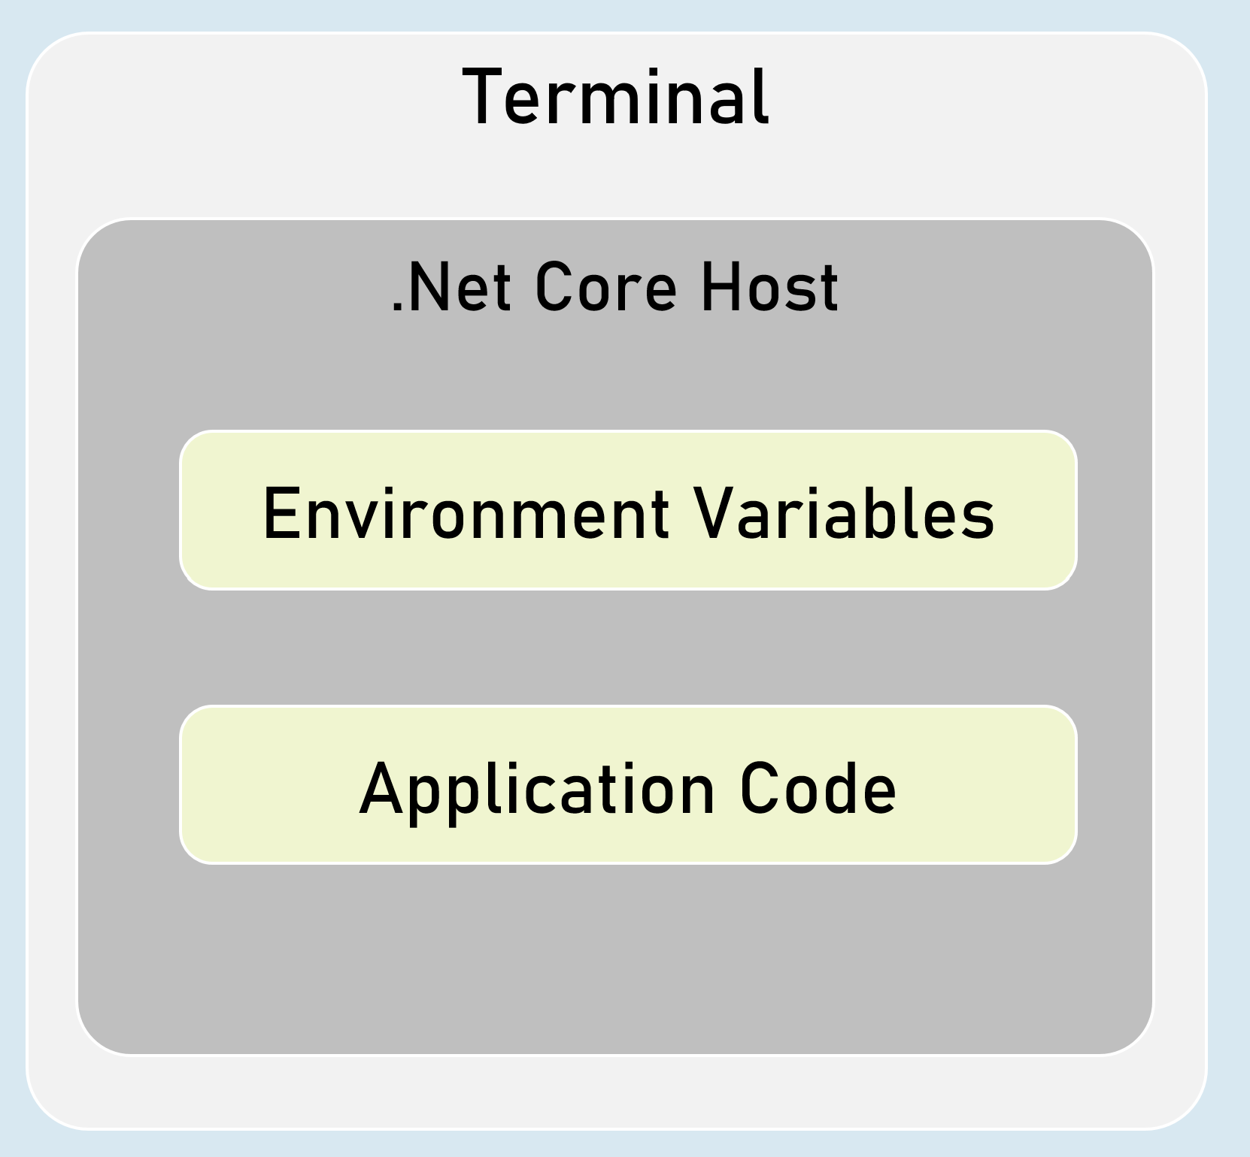

You can set configuration values as in-process environment variables.

**Set Configuration as Environment Variables**

in "Windows PowerShell" / "Developer PowerShell in VS":

$Env:ParentKey__ChildKey="value"

dotnet run --no-launch-profile

It is one of the most secured way of setting-up sensitive values in configuration.

__ (underscore and underscore) is the separator between parent key and child key.

**Custom Json Configuration**

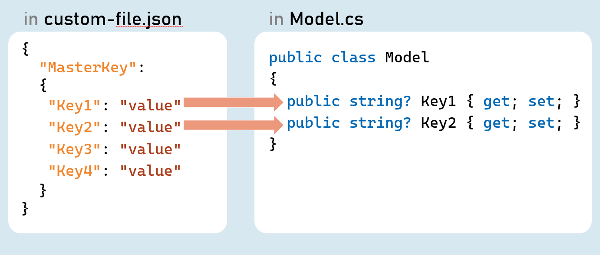

**Add Custom Json file as Configuration Source**

in Program.cs:

builder.Host.ConfigureAppConfiguration( (hostingContext, config) => {

config.AddJsonFile("filename.json", optional: true, reloadOnChange: true);

});

**Http Client**

HttpClient is a class for sending HTTP requests to a specific HTTP resource (using its URL) and receiving HTTP responses from the same.

Examples: Making a request to a third-party weather API, ChatGPT etc.

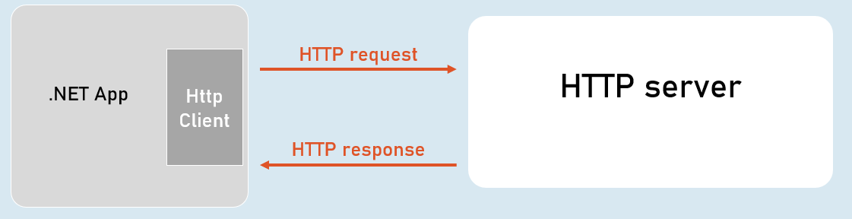

**IHttpClientFactory**

IHttpClientFactory is an interface that provides a method called CreateClient() that creates a new instance of HttpClient class and also automatically disposes the same instance (closes the connection) immediately after usage.

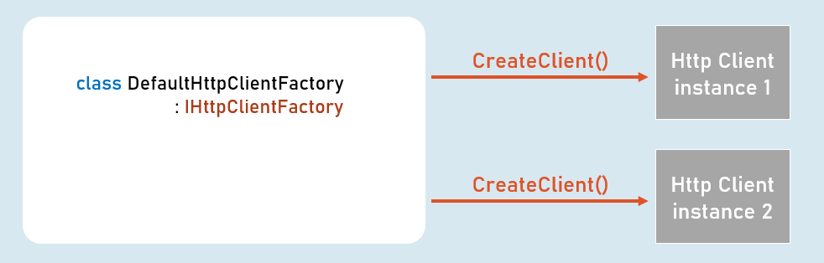

**HttpClient**

**Properties**

* BaseAddress
* DefaultRequestHeaders

**Methods**

* GetAsync()
* PostAsync()
* PutAsync()
* DeleteAsync()